TO USE: Print cut on dotted lines and then print your name under “Crocheted by” wrap around washcloth an tape to staple closed

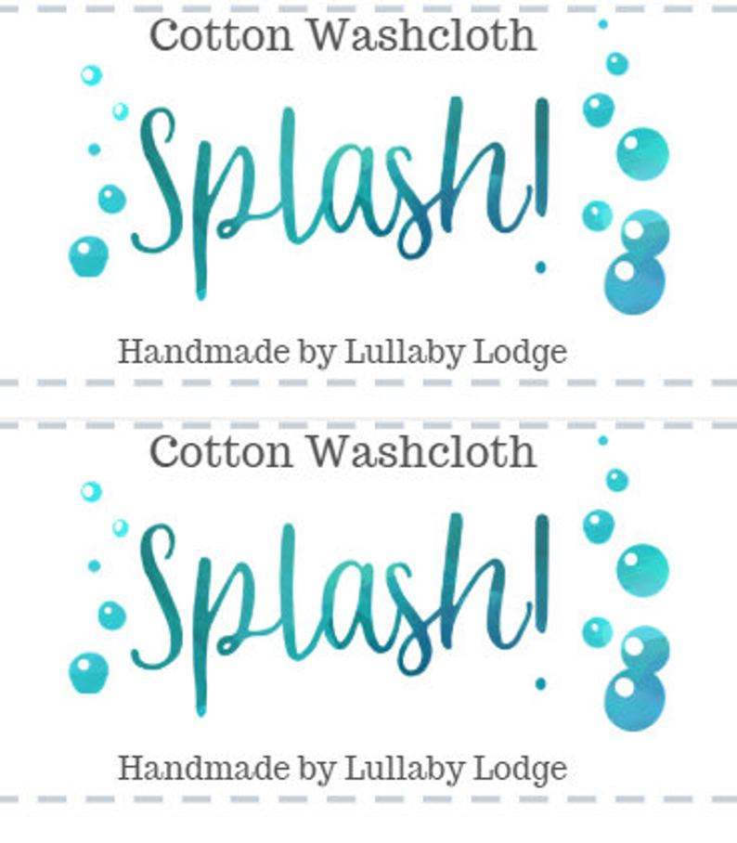
Crocheted by __________________________
Crocheted by __________________________
Stitch n’ Chicks
Stitch n’ Chicks

